EXPERIMENT 4

RELATIONAL MODEL FOR SAILOR BOAT DATABASE

**Aim:** Draw a relational model for sailors’ database.

**Components:**

1. Tables:
   1. Sailor
   2. Boat
   3. Reserves
2. Degree
   1. Sailor – 4
   2. Boat – 3
   3. Reserves – 1

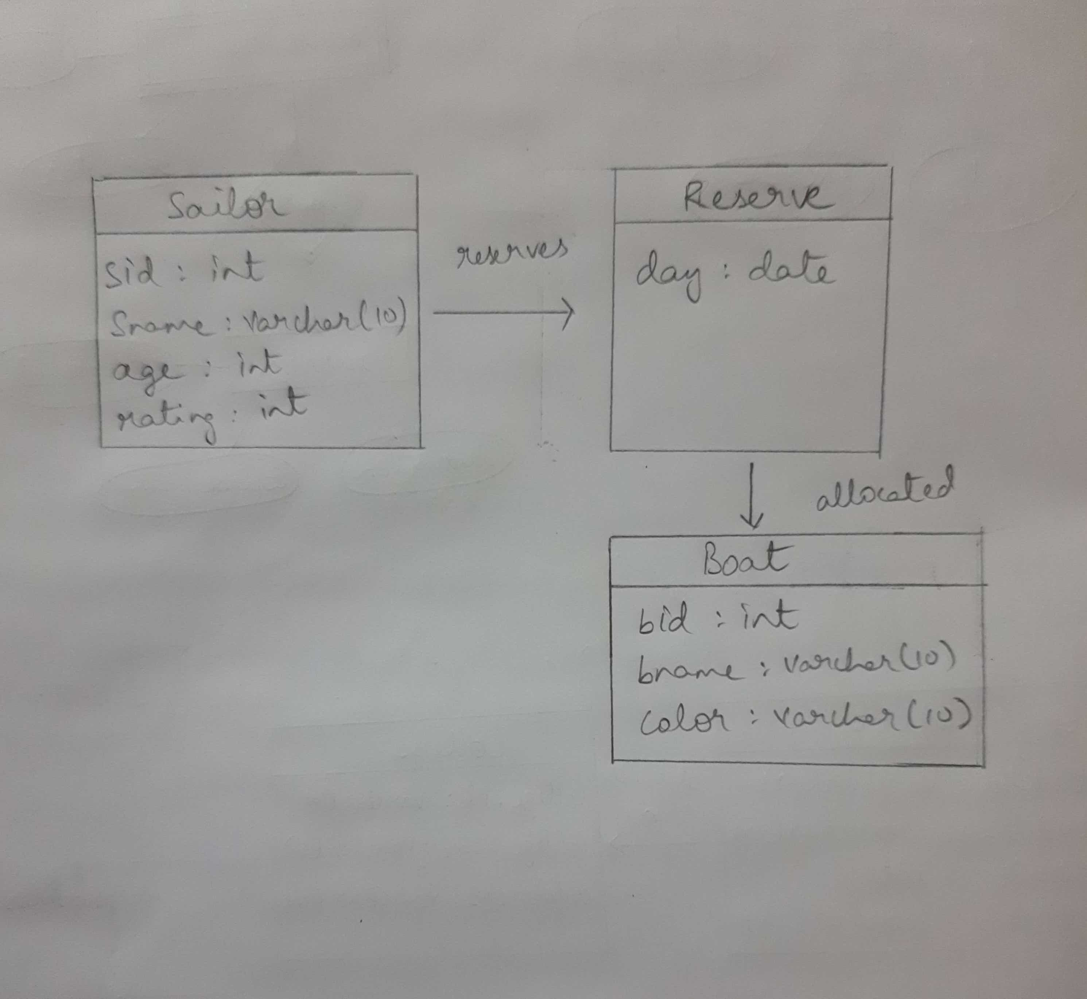

|  |
| --- |
| Sailor |
| sid int |
| sname varchar(10) |
| age int |
| rating int |

|  |
| --- |
| Reserves |
| day date |
|  |
|  |
|  |

allocated

|  |
| --- |
| Boats |
| bid int |
| bname varchar(10) |
| color varchar(5) |
|  |